Table 7: Manufacturer Product Overview
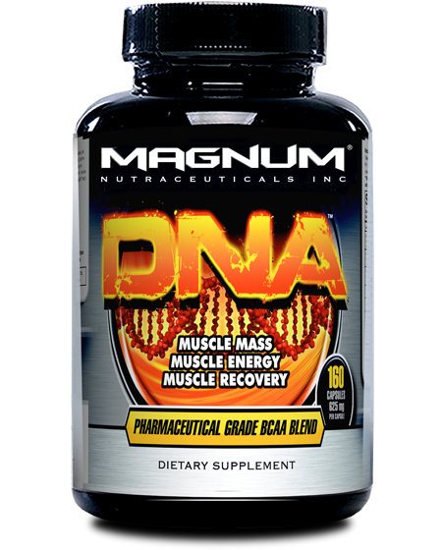
What is Magnum DNA®?
Magnum DNA® is an anabolic formula that combines the powerful muscle-regenerating effects of Branched Chain Amino Acids (BCAAs) with the hardening and muscle expanding Glycine/Arginine ingredient. DNA® also contains the intense anabolism-triggering ingredient L-Leucine Alpha KIC to ensure the most complete, natural muscle gains rarely produced in a non-hormonal supplement. These scientifically proven ingredients have been known to improve density of muscles and strength, recovery and athletic performance. Only a formula this concentrated comes with a 3-day strength guarantee!* Branched Chain Amino Acids (BCAAs) are known as the building blocks of muscle. They must be present for muscle development and growth. The essential BCAAs are leucine, isoleucine and valine. These BCAAs are classified as “essential” because the human body does not produce them – they must be taken through supplementation.
Magnum DNA® produced the following results
• Instant strength • Improved recovery • Increased endurance • Increased protein synthesis (utilization of protein) • Long-term increased lean muscle mass • Long-term muscle hardening and definition
What is unique about Magnum DNA®?
• It offers 7 of the most innovative, pure, Pharmaceutical Grade sources of BCAAs, including the latest Ethyl Ester & Ketoisocaproate Calcium technology • Ethyl Ester is the first bonding molecule to pass the blood-brain barrier, thus effectively saturating every cell in the body with a larger dose of the attached BCAA • Ketoisocaproate Calcium (KIC) is perfectly anti-catabolic – it assists in muscle growth by changing the environment in your body from catabolic (muscle wasting) to anabolic (muscle building) • It also supplies a potent dose of Glycine-L-Arginine – an ingredient scientifically proven to enhance muscle performance and recovery from fatigue by sustaining muscle force and overall output

Manufacturer Product Overview
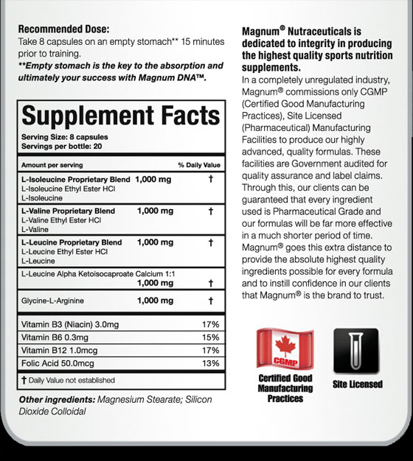
Who is Magnum DNA® meant for?
Uses weights with their training program • Is looking to improve strength and endurance • Is trying to increase lean muscle mass & improve body composition • Is a bodybuilder, fitness competitor or athlete
The World’s 1st Pharmaceutical Grade Anabolic Activating Experience!
An extremely anabolic pre-workout formula unlike any other! DNA users routinely report that they are able to do more reps with the same weight from their previous workout from their very first dose! Strength, power, recovery, endurance & muscle hardening all attained within 3 days! DNA is truly an awesome supplement because it's the only BCAA based anabolic formula that you will feel from your very first workout.
How to use zzzzzzzzzzzzzzzzzzzzzzzzzzzzzzzzzzzzzzzzzzzzzzzzzzzzzzzzzzzzzzzzzzz
Serving Size 8 capsules 160 capsules per bottle
Recommended Dose: Take 8 capsules on an empty stomach** 15 minutes prior to training **Empty stomach is the key to the absorption and ultimately your success with Magnum DNA

